UI Guidelines

References:

# Coordinate System:

Coordinate system is from a minimum of (0,0) to (1600,900), as demonstrated below.

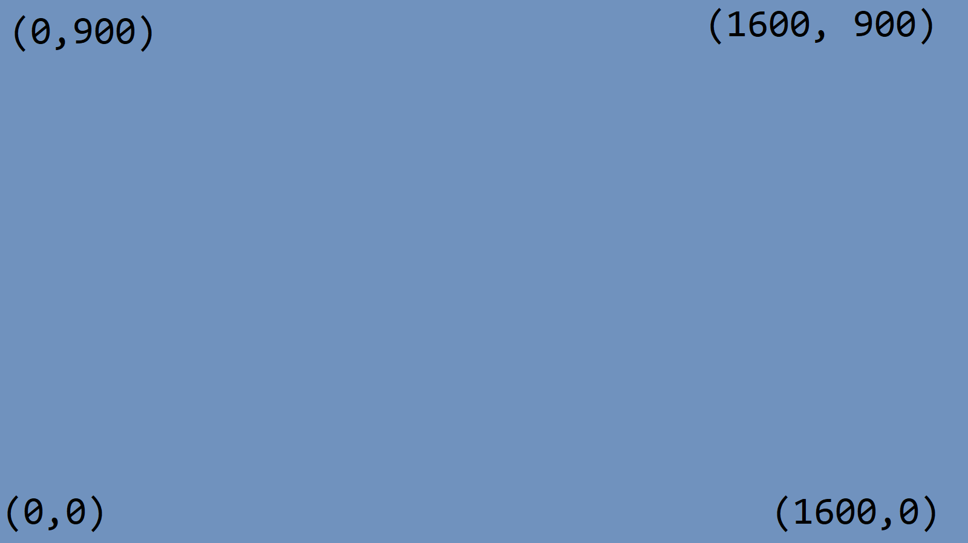

Properties:

# Size

## Definition:

## Defines the minimum size for a widget. Widget is guaranteed to be at least this size.

## Usage:



## Example:



# Offset

## Definition:

Offsets the current widget by the (x,y) amount specified.

## Usage:



## Example:



# Border

## Definition:

Adds a border surrounding the widget by an even amount on all sides.

## Usage:



## Example:





# Padding

## Definition:

Adds extra space to the minimum size, pushing out the borders.

## Usage:



## Example:



# Name

## Definition:

## Usage:

## Example:

# Name

## Definition:

## Usage:

## Example:

# Name

## Definition:

## Usage:

## Example:

# Name

## Definition:

## Usage:

## Example: